Welcome to
Trinity Lutheran Church
Lutheran Church—Missouri Synod
A Stephen Ministry Congregation

1354 South Otsego Avenue
Gaylord, Michigan 49735
Church Phone: (989) 732-4816

Church Email: secretary@trinitygaylord.com
www.trinitygaylord.com

Office Hours: Monday through Friday 9am – 1pm

OUR PURPOSE
…is to LOVE GOD, LOVE OTHERS, AND SERVE THE WORLD by worshiping the Lord Jesus, bringing our members into Christ-like maturity, and equipping them through Word and Sacrament for their mission and ministry. We go heart to heart into the world with Jesus, sharing His love, caring for one another, praying, and bringing the lost into a relationship with Christ, by the working of the Holy Spirit.

May 22, 2022
Sixth Sunday of Easter
Preacher: Rev. Ken Bernthal

ABOUT OUR WORSHIP
We welcome all who gather here today! We are blessed to celebrate together the mercy, grace, and love we have from God through the death and resurrection of our Lord Jesus Christ.

Children: Families with children are very welcome here. Having children in church is important so they can begin to learn about their faith in Jesus, and it’s good for the whole congregation to see. Please feel comfortable keeping “squirmy” kids in the service. This is where they belong, too!

Pew Cards: Guests and Members, please fill out the Guest/Member card located on the back of the pew in front of you and pass it to the end of the aisle. If you forget you can put it in the offering plate on your way out.

If standing is difficult: Please feel free to remain seated during any portion of the service. Please let an Elder or Usher know if you need communion in your pew seat.

About our celebration of Holy Communion: We celebrate the Lord’s Supper in the confession and glad confidence that, as he says, our Lord gives into our mouths not only bread and wine but his very body and blood to eat and to drink for the forgiveness of sins and to strengthen our union with him and with one another. Our Lord invites to his table those who trust his words, repent of all sin, and set aside any refusal to forgive and love as he forgives and loves us, that they may show forth his death until he comes.

Because those who eat and drink our Lord’s body and blood contrary to that which is stated above do so to their great harm, and also because Holy Communion is a confession of the faith which is confessed at this altar. Anyone who is not yet instructed, in doubt, or who hold a confession differing from that of the Lutheran Church—Missouri Synod, and yet desire to receive the sacrament, are asked first to speak with Pastor. Those not communing are still invited to come forward for a blessing from Pastor, and you may indicate this by crossing your arms over your chest.
TTTTTT

GREETING
P Peace be with you.
C And also with you.
T ORDER OF SERVICE T
(The liturgy is from Divine Service Setting four LSB pg. 203ff)

OPENING HYMN
Rejoice, O Pilgrim Throng LSB 813 sts.1–4
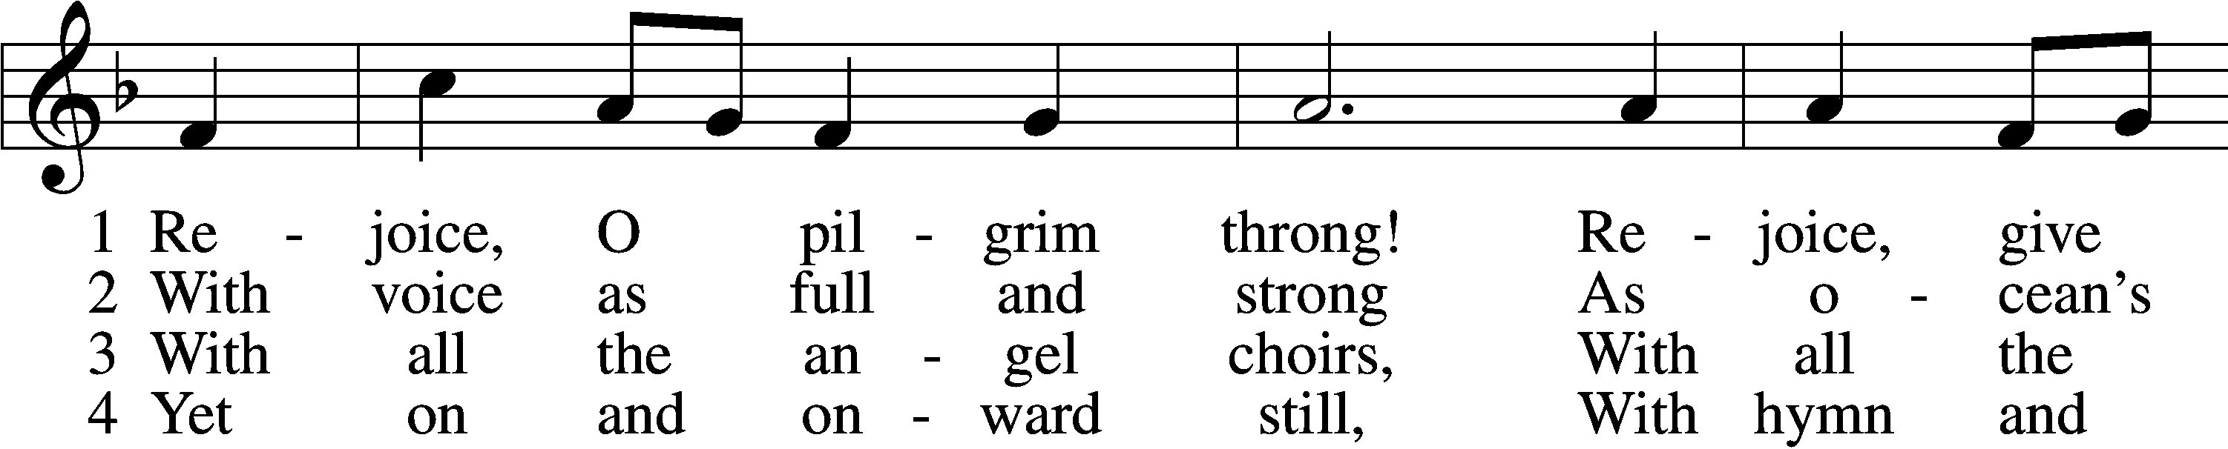
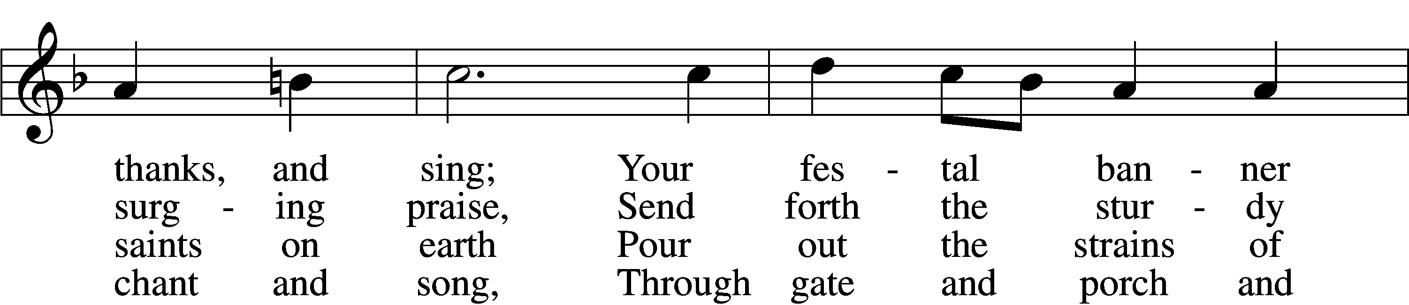
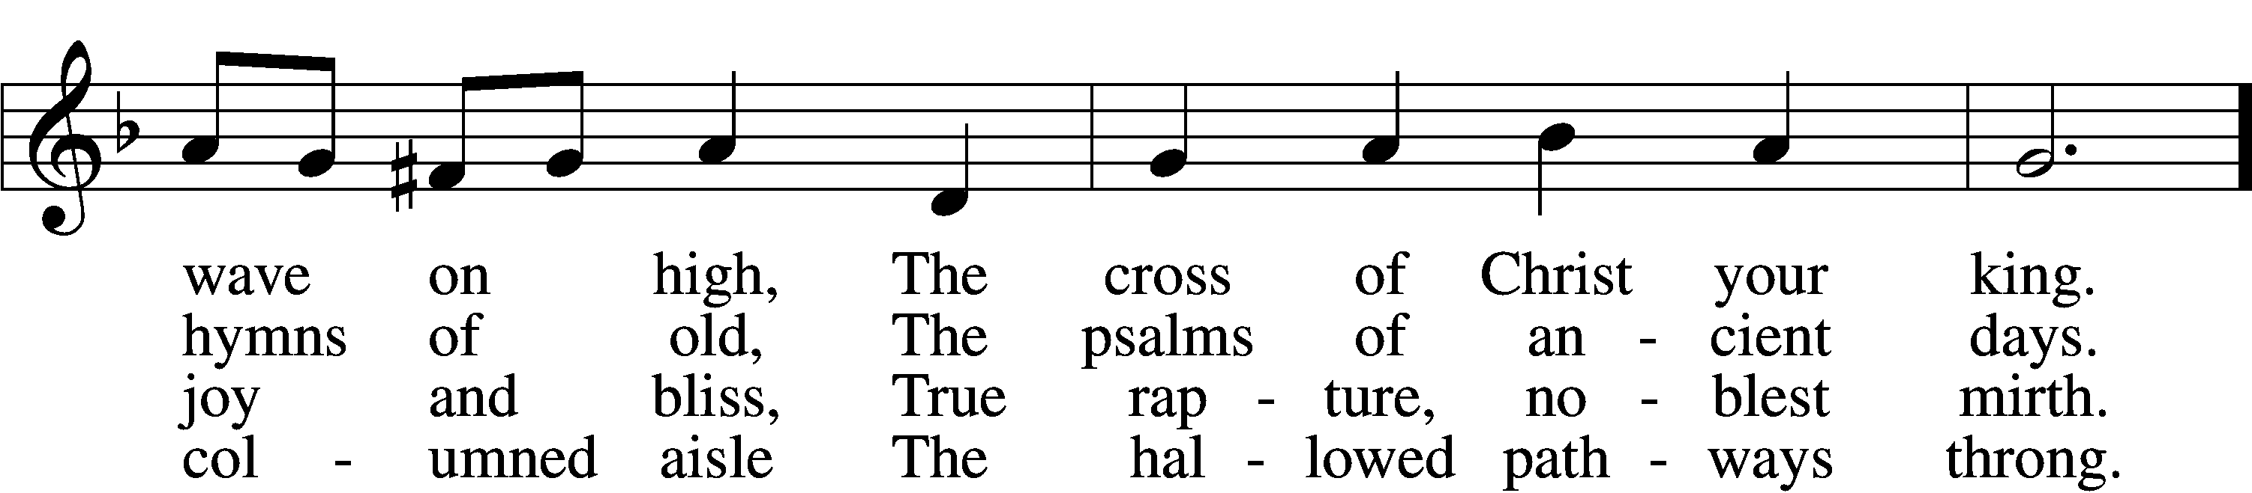
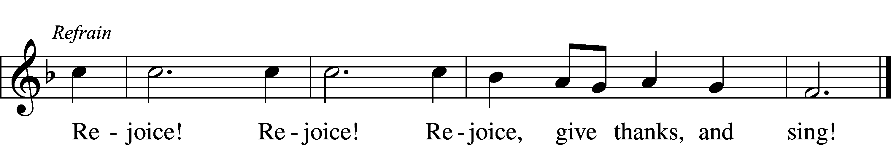
Text: Edward H. Plumptre, 1821–91, alt.
Tune: Arthur H. Messiter, 1834–1916
Text and tune: Public domain

Please stand as able

CONFESSION and ABSOLUTION

The sign of the cross may be made by all in remembrance of their Baptism.

P In the name of the Father and of the T Son and of the Holy Spirit.
C Amen.
P Our help is in the name of the Lord,
C who made heaven and earth.
P If You, O Lord, kept a record of sins, O Lord, who could stand?
C But with You there is forgiveness; therefore, You are feared.
P Since we are gathered to hear God’s Word, call upon Him in prayer and praise, and receive the body and blood of our Lord Jesus Christ in the fellowship of this altar, let us first consider our unworthiness and confess before God and one another that we have sinned in thought, word, and deed, and that we cannot free ourselves from our sinful condition. Together as His people let us take refuge in the infinite mercy of God, our heavenly Father, seeking His grace for the sake of Christ, and saying: God, be merciful to me, a sinner.
C Almighty God, have mercy upon us, forgive us our sins, and lead us to everlasting life. Amen.
P Almighty God, merciful Father, in Holy Baptism You declared us to be Your children and gathered us into Your one, holy Church, in which You daily and richly forgive us our sins and grant us new life through Your Spirit. Be in our midst, enliven our faith, and graciously receive our prayer and praise; through Your Son, Jesus Christ, our Lord.
C Amen.

SERVICE OF THE WORD

INTROIT Psalm 55:4, 16–18; antiphon: v. 22
P Cast your burden on the Lord, and he will sustain you;
he will never permit the righteous to be moved.
C My heart is in anguish within me;
terrors of death have fallen upon me.
P But I call to God,
and the Lord will save me.
C Evening and morning and at noon I utter my complaint and moan,
and he hears my voice.
P He redeems my soul in safety from the battle that I wage,
for many are arrayed against me.
ALL Glory be to the Father and to the Son
and to the Holy Spirit;
as it was in the beginning,
is now, and will be forever. Amen.
C Cast your burden on the Lord, and he will sustain you;
he will never permit the righteous to be moved.

KYRIE LSB 204
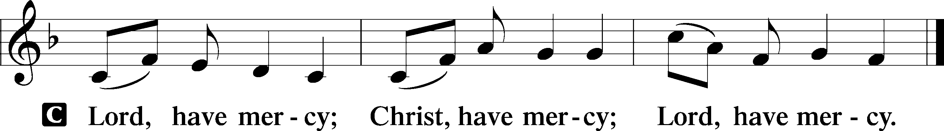

GLORIA IN EXCELSIS LSB 204
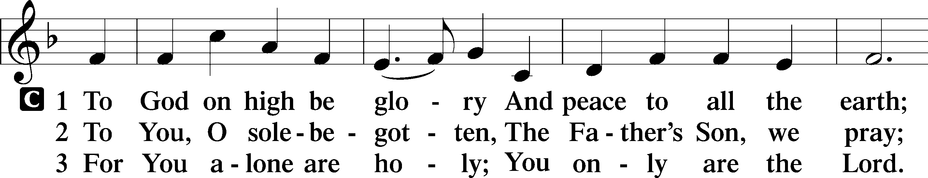
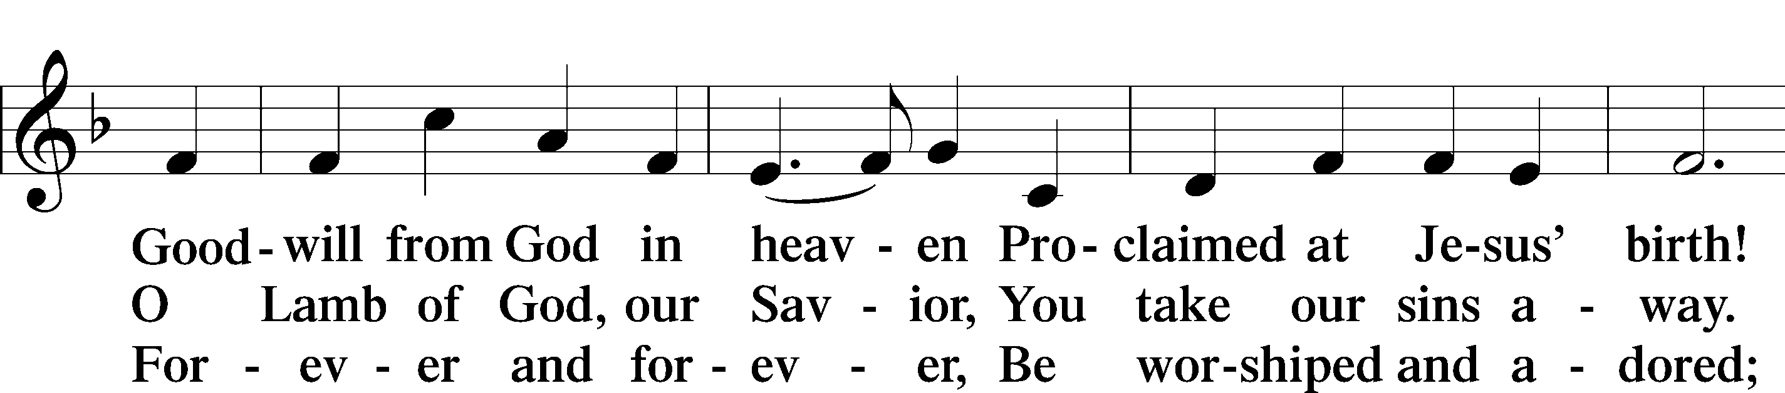
Continued on next page
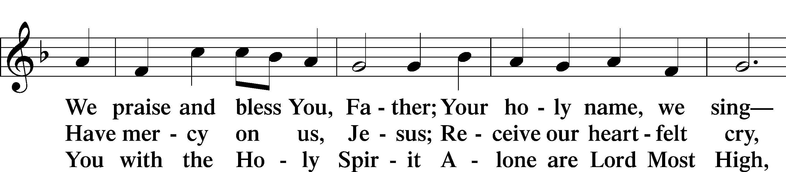
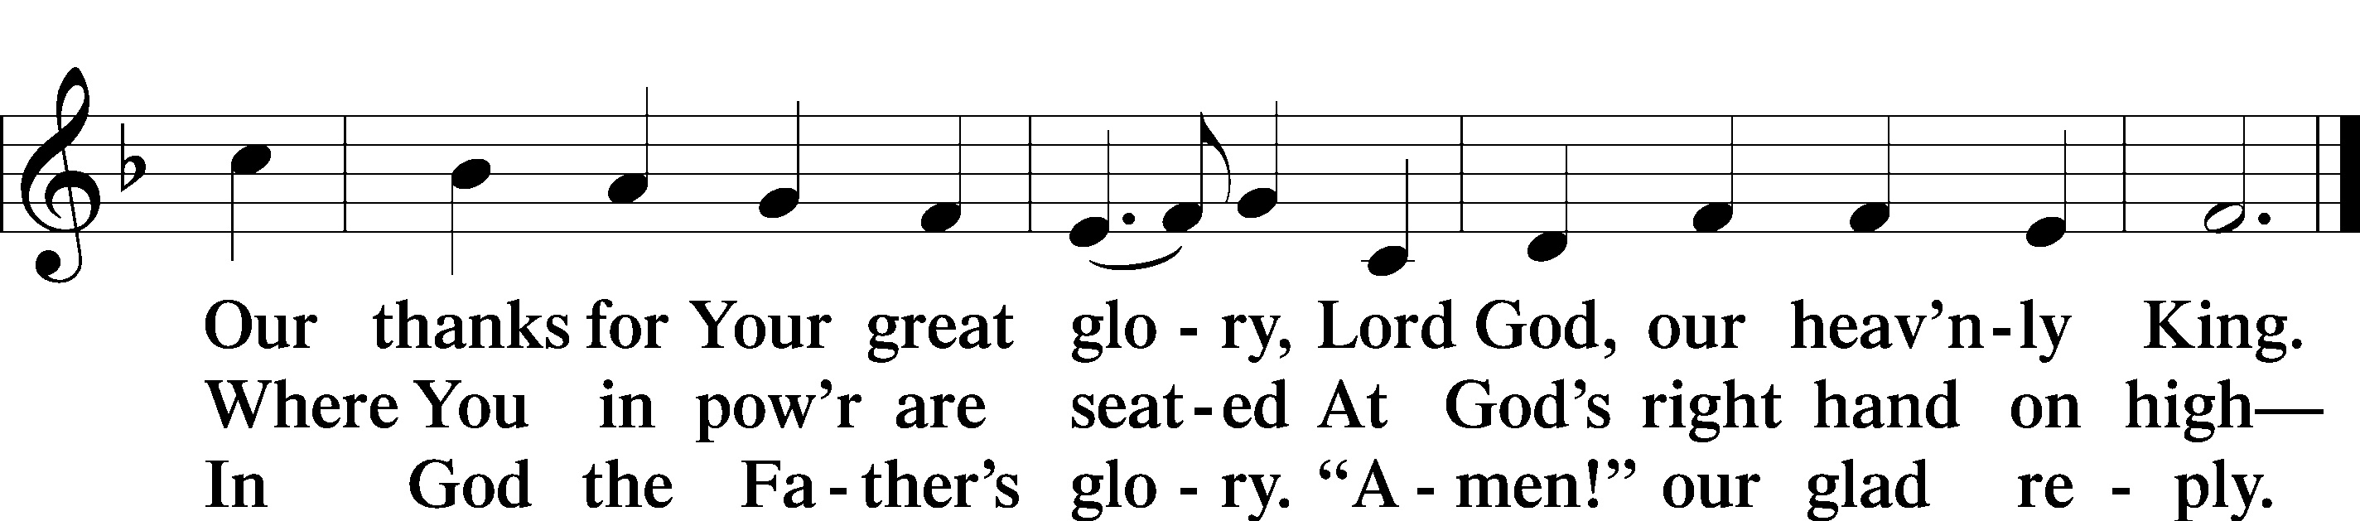
Text: Stephen P. Starke

SALUTATION AND COLLECT OF THE DAY
P The Lord be with you.
C And also with you.

P Let us pray.
O God, the giver of all that is good, by Your holy inspiration grant that we may think those things that are right and by Your merciful guiding accomplish them; through Jesus Christ, Your Son, our Lord, who lives and reigns with You and the Holy Spirit, one God, now and forever.
C Amen.

Please be seated

FIRST READING Acts 16:9–15
⁹A vision appeared to Paul in the night: a man of Macedonia was standing there, urging him and saying, “Come over to Macedonia and help us.” ¹⁰And when Paul had seen the vision, immediately we sought to go on into Macedonia, concluding that God had called us to preach the gospel to them.
¹¹So, setting sail from Troas, we made a direct voyage to Samothrace, and the following day to Neapolis, ¹²and from there to Philippi, which is a leading city of the district of Macedonia and a Roman colony. We remained in this city some days. ¹³And on the Sabbath day we went outside the gate to the riverside, where we supposed there was a place of prayer, and we sat down and spoke to the women who had come together. ¹⁴One who heard us was a woman named Lydia,

from the city of Thyatira, a seller of purple goods, who was a worshiper of God. The Lord opened her heart to pay attention to what was said by Paul. ¹⁵And after she was baptized, and her household as well, she urged us, saying, “If you have judged me to be faithful to the Lord, come to my house and stay.” And she prevailed upon us.

P This is the Word of the Lord.
C Thanks be to God.

EPISTLE Revelation 21:9–14, 21–27
⁹Then came one of the seven angels who had the seven bowls full of the seven last plagues and spoke to me, saying, “Come, I will show you the Bride, the wife of the Lamb.” ¹⁰And he carried me away in the Spirit to a great, high mountain, and showed me the holy city Jerusalem coming down out of heaven from God, ¹¹having the glory of God, its radiance like a most rare jewel, like a jasper, clear as crystal. ¹²It had a great, high wall, with twelve gates, and at the gates twelve angels, and on the gates the names of the twelve tribes of the sons of Israel were inscribed— ¹³on the east three gates, on the north three gates, on the south three gates, and on the west three gates. ¹⁴And the wall of the city had twelve foundations, and on them were the twelve names of the twelve apostles of the Lamb. . . .
²¹And the twelve gates were twelve pearls, each of the gates made of a single pearl, and the street of the city was pure gold, transparent as glass.
²²And I saw no temple in the city, for its temple is the Lord God the Almighty and the Lamb. ²³And the city has no need of sun or moon to shine on it, for the glory of God gives it light, and its lamp is the Lamb. ²⁴By its light will the nations walk, and the kings of the earth will bring their glory into it, ²⁵and its gates will never be shut by day—and there will be no night there. ²⁶They will bring into it the glory and the honor of the nations. ²⁷But nothing unclean will ever enter it, nor anyone who does what is detestable or false, but only those who are written in the Lamb’s book of life.

P This is the Word of the Lord.
C Thanks be to God.
Please stand as able

ALLELUIA AND VERSE LSB 205
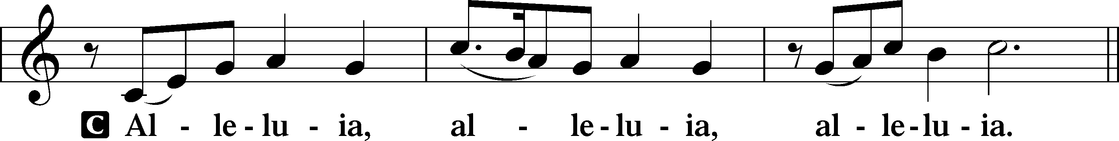

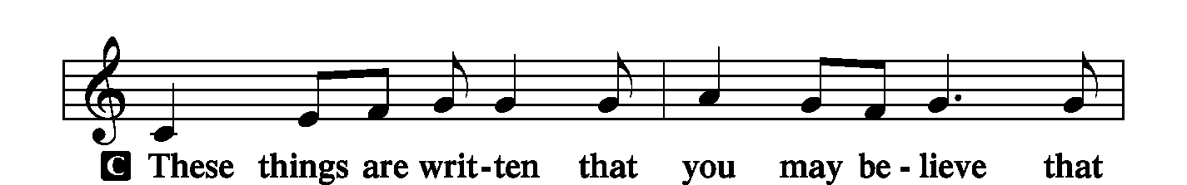
Continued on next page
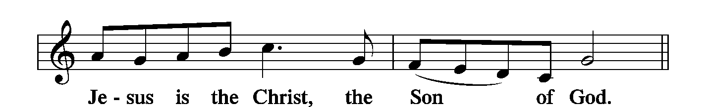
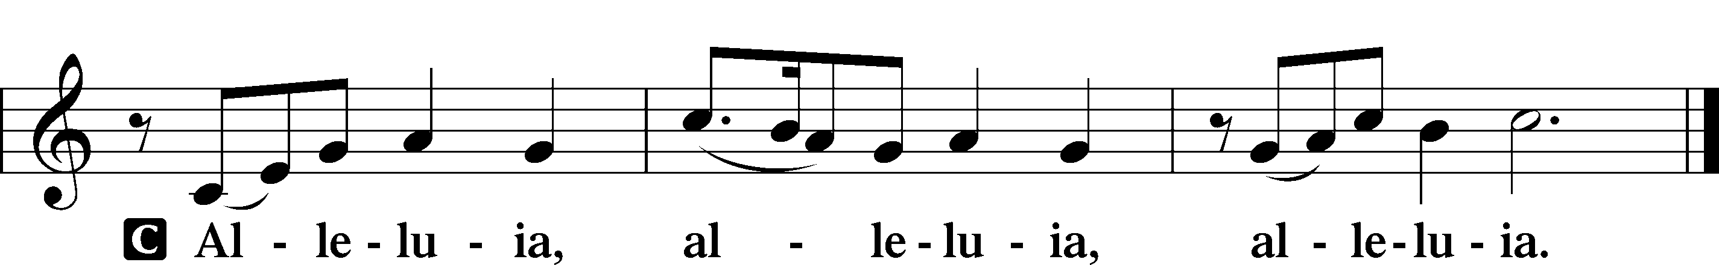

HOLY GOSPEL John 16:23–33
P The Holy Gospel according to St. John, the sixteenth chapter.
C Glory to You, O Lord.

²³[Jesus said:] “In that day you will ask nothing of me. Truly, truly, I say to you, whatever you ask of the Father in my name, he will give it to you. ²⁴Until now you have asked nothing in my name. Ask, and you will receive, that your joy may be full.
²⁵“I have said these things to you in figures of speech. The hour is coming when I will no longer speak to you in figures of speech but will tell you plainly about the Father. ²⁶In that day you will ask in my name, and I do not say to you that I will ask the Father on your behalf; ²⁷for the Father himself loves you, because you have loved me and have believed that I came from God. ²⁸I came from the Father and have come into the world, and now I am leaving the world and going to the Father.”
²⁹His disciples said, “Ah, now you are speaking plainly and not using figurative speech! ³⁰Now we know that you know all things and do not need anyone to question you; this is why we believe that you came from God.” ³¹Jesus answered them, “Do you now believe? ³²Behold, the hour is coming, indeed it has come, when you will be scattered, each to his own home, and will leave me
alone. Yet I am not alone, for the Father is with me. ³³I have said these things to you, that in me you may have peace. In the world you will have tribulation. But take heart; I have overcome the world.”

P This is the Gospel of the Lord.
C Praise to You, O Christ.

NICENE CREED
C I believe in one God,
the Father Almighty,
maker of heaven and earth
and of all things visible and invisible.
And in one Lord Jesus Christ,
the only-begotten Son of God,
begotten of His Father before all worlds,
God of God, Light of Light,
very God of very God,
begotten, not made,
being of one substance with the Father,
by whom all things were made;
who for us men and for our salvation came down from heaven
and was incarnate by the Holy Spirit of the virgin Mary
and was made man;
and was crucified also for us under Pontius Pilate.
He suffered and was buried.
And the third day He rose again according to the Scriptures
and ascended into heaven
and sits at the right hand of the Father.
And He will come again with glory to judge both the living and the dead,
whose kingdom will have no end.
And I believe in the Holy Spirit,
the Lord and giver of life,
who proceeds from the Father and the Son,
who with the Father and the Son together is worshiped and glorified,
who spoke by the prophets.
And I believe in one holy Christian and apostolic Church,
I acknowledge one Baptism for the remission of sins,
and I look for the resurrection of the dead
and the life T of the world to come. Amen.
Please be seated

“ALL GOD’S CHILDREN” TALK
SERMON HYMN
Rejoice, O Pilgrim Throng LSB 813 sts. ref, 5–7Stand on st.7
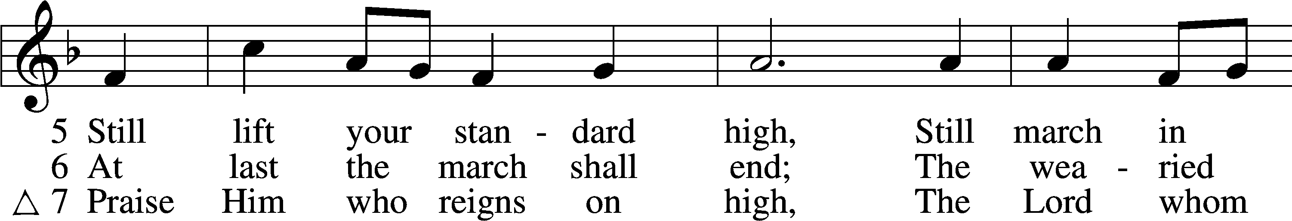
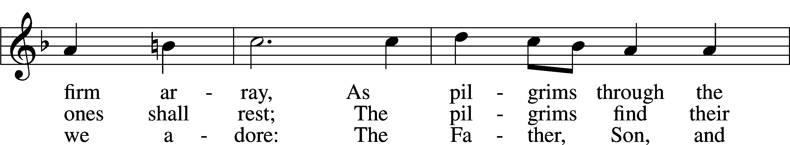
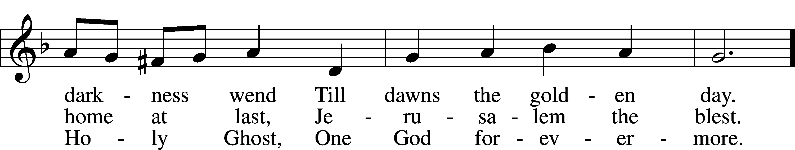
Text: Edward H. Plumptre, 1821–91, alt.
Tune: Arthur H. Messiter, 1834–1916
Text and tune: Public domain
SERMON

Please stand as able

PRAYER of the CHURCH
After each Segment:
P Lord, in Your Mercy,
C Hear our Prayer.
After Final Segment:
P Hear us as we pray in His name and as He has taught us:
LORD’S PRAYER
C Our Father who art in heaven,
hallowed be Thy name,
Thy kingdom come,
Thy will be done on earth
as it is in heaven;
give us this day our daily bread;
and forgive us our trespasses
as we forgive those
who trespass against us;
and lead us not into temptation,
but deliver us from evil.
For Thine is the kingdom
and the power and the glory
forever and ever. Amen.

SERVICE of the SACRAMENT
PREFACE LSB 208
P The Lord be with you.
C And also with you.
P Lift up your hearts.
C We lift them to the Lord.

P Let us give thanks to the Lord our God.
C It is right to give Him thanks and praise.

P It is truly good, right, and salutary that we should at all times and in all places give thanks to You, O Lord, holy Father, almighty and everlasting God, for the countless blessings You
so freely bestow on us and all creation. Above all, we give thanks for Your boundless love shown to us when You sent Your only-begotten Son, Jesus Christ, into our flesh and laid on Him our sin, giving Him into death that we might not die eternally. Because He is now risen from the dead and lives and reigns to all eternity, all who believe in Him will overcome sin
and death and will rise again to new life. Therefore with angels and archangels and with all the company of heaven we laud and magnify Your glorious name, evermore praising You and singing:

SANCTUS LSB 208
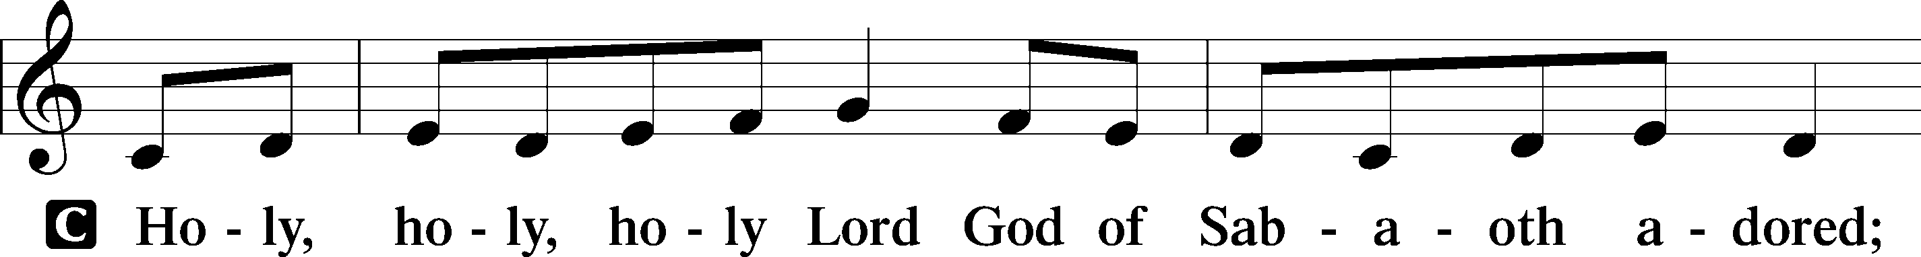
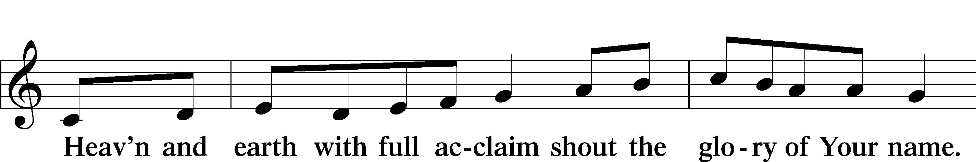
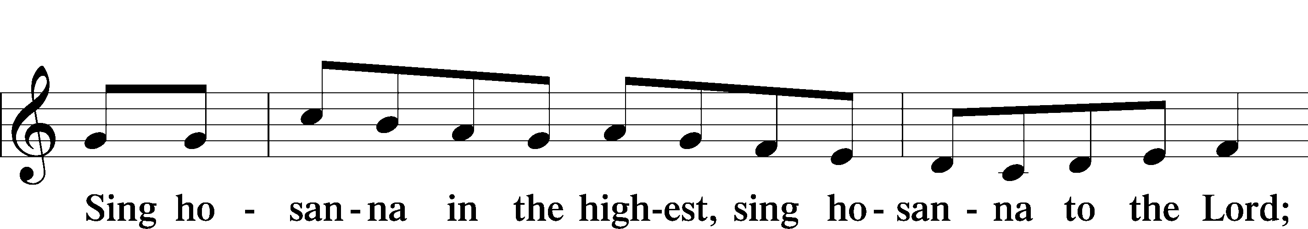

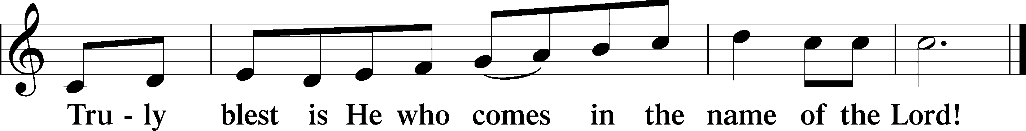

THE WORDS OF OUR LORD
P Our Lord Jesus Christ, on the night when He was betrayed, took bread, and when He had given thanks, He broke it and gave it to the disciples and said: “Take, eat; this is My T body, which is given for you. This do in remembrance of Me.”
In the same way also, He took the cup after supper, and when He had given thanks, He gave it to them, saying: “Drink of it, all of you; this cup is the New Testament in My T blood, which is shed for you for the forgiveness of sins. This do, as often as you drink it, in remembrance of Me.”

PAX DOMINI
P The peace of the Lord be with you always.
C Amen.
AGNUS DEI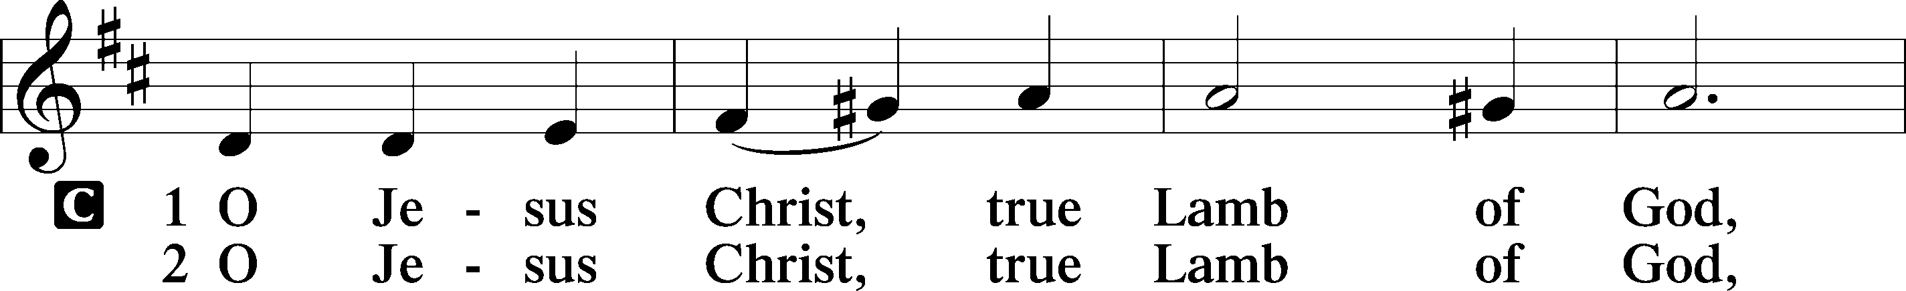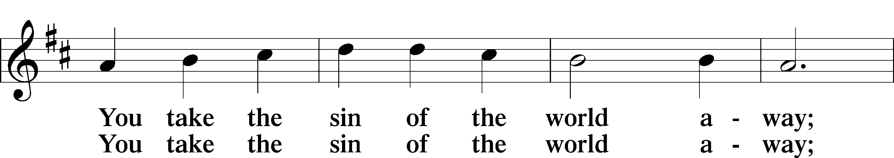
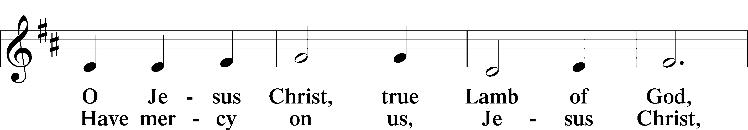
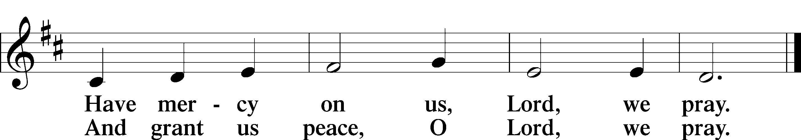

Please be seated
DISTRIBUTION
The pastor and those who assist him receive the body and blood of Christ first, then Communion will be served at the rail.. Ushers will help direct you forward via the center aisle; please return to your seats via the side aisles. Gluten-free bread is available for those who need it, as is non-alcoholic grape juice. Simply request either when you come forward to receive Communion.
DISTRIBUTION HYMN
Jesus, Thy Blood and Righteousness LSB 563
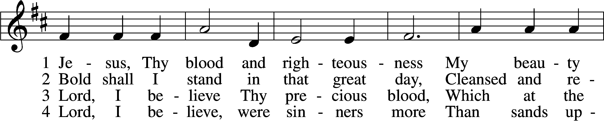
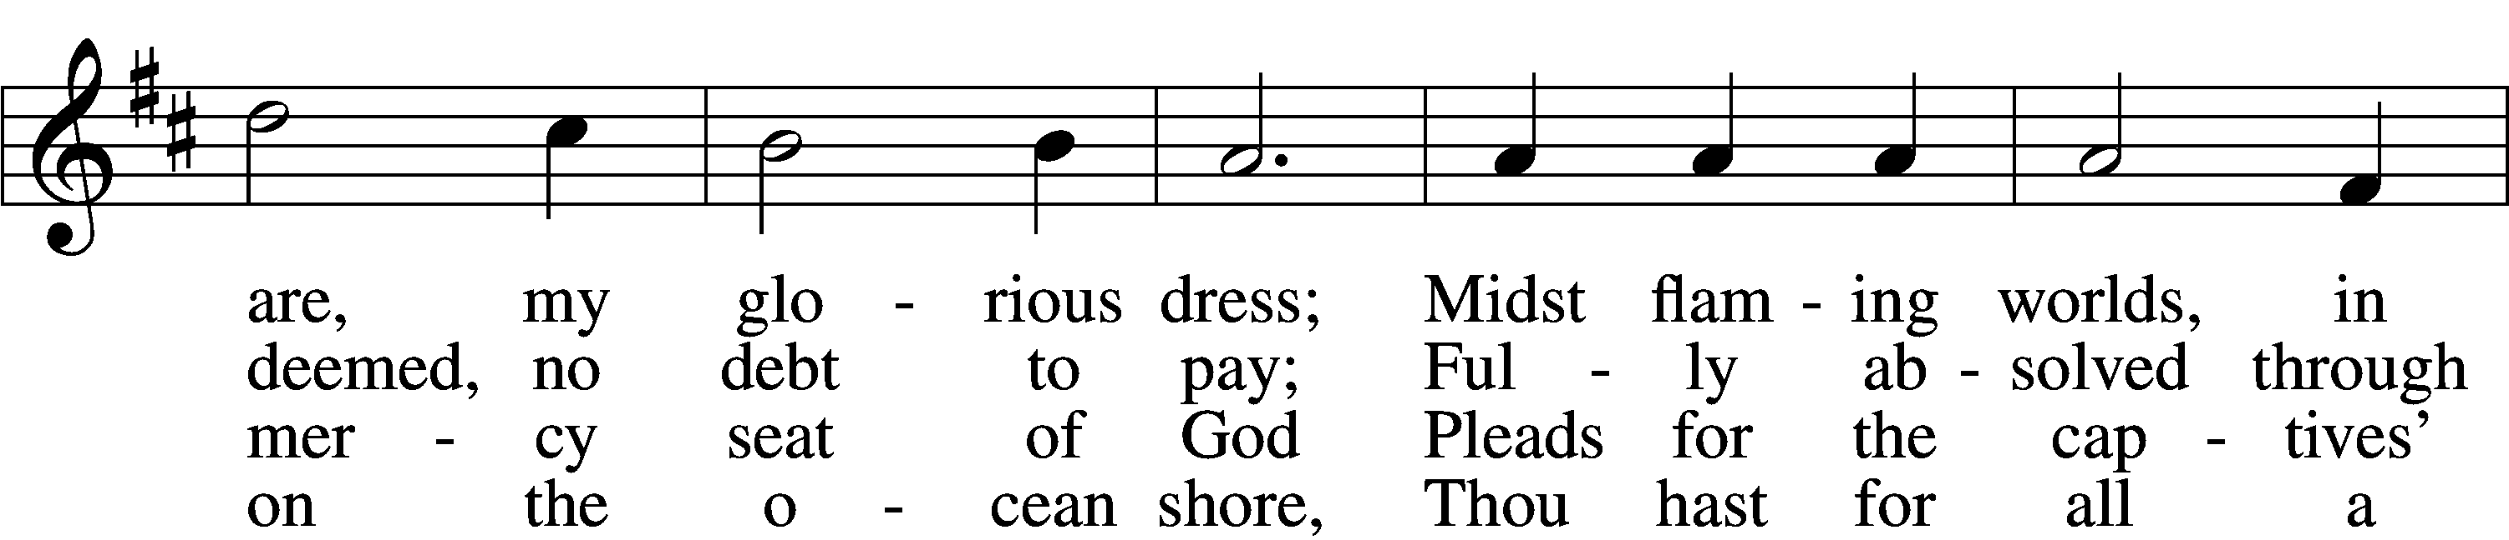
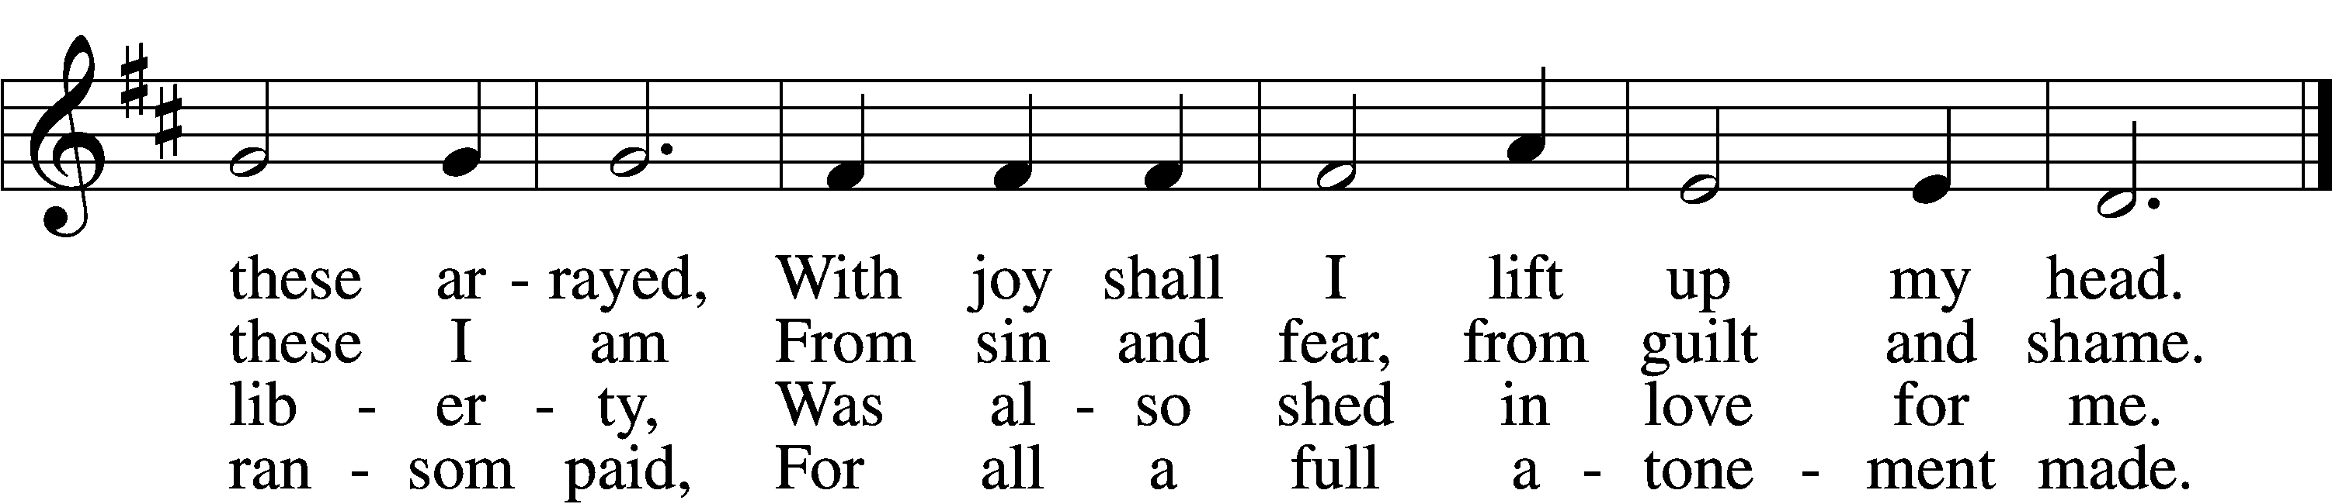

5 When from the dust of death I rise
To claim my mansion in the skies,
This then shall be my only plea:
Jesus hath lived and died for me.

6 Jesus, be endless praise to Thee,
Whose boundless mercy hath for me,
For me, and all Thy hands have made,
An everlasting ransom paid.

Text: Nicolaus Ludwig von Zinzendorf, 1700–60; tr. John B. Wesley, 1703–91, alt.
Tune: George J. Elvey, 1816–93
Text and tune: Public domain

Please stand as able

NUNC DIMITTIS LSB 211
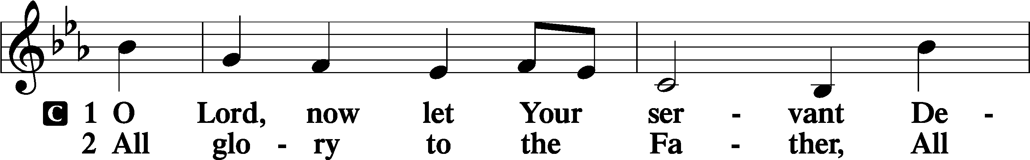
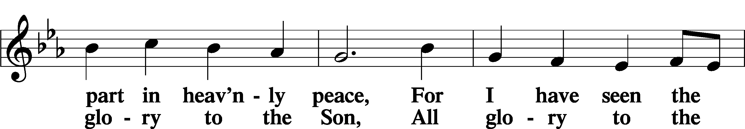
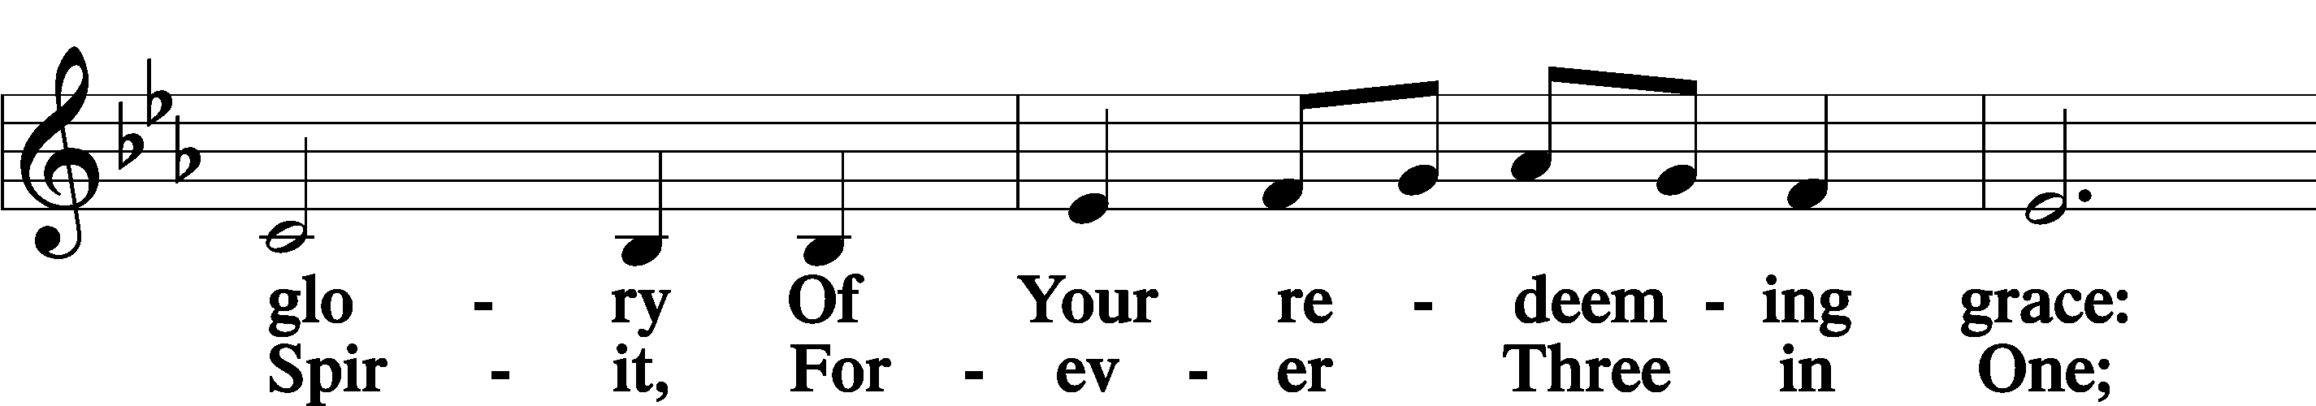
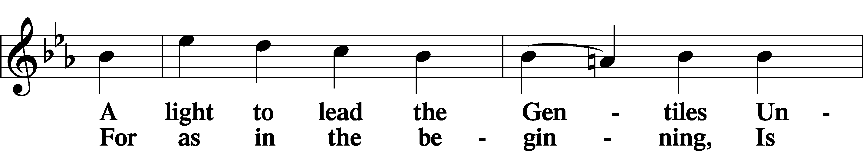
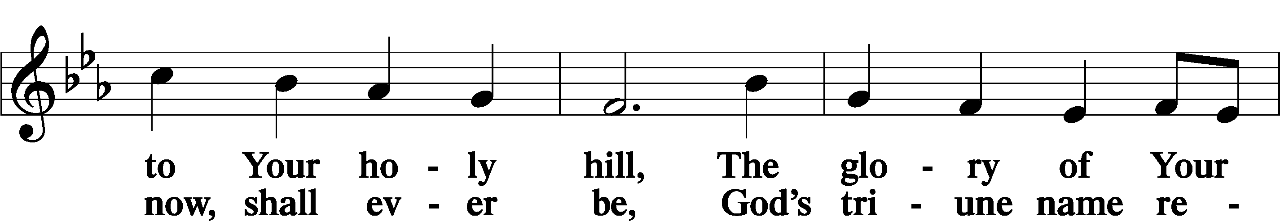
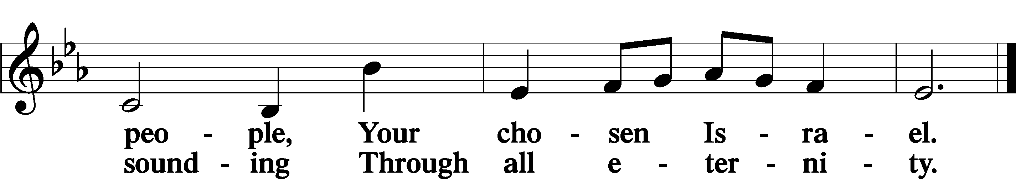

POST COMMUNION COLLECT
P Let us pray.
O God the Father, the fountain and source of all goodness, who in loving-kindness sent Your only-begotten Son into the flesh, we thank You that for His sake You have given us pardon and peace in this Sacrament, and we ask You not to forsake Your children but always to rule our hearts and minds by Your Holy Spirit that we may be enabled constantly to serve You; through Jesus Christ, Your Son, our Lord, who lives and reigns with You and the Holy Spirit, one God, now and forever.
C Amen.

BENEDICAMUS LSB 212
P Let us bless the Lord.
C Thanks be to God.
BENEDICTION
P The Lord bless you and keep you.
The Lord make His face shine on you and be gracious to you.
The Lord look upon you with favor and T give you peace.
C Amen.

Please be seated
CLOSING HYMN
Ye Watchers and Ye Holy Ones LSB 670
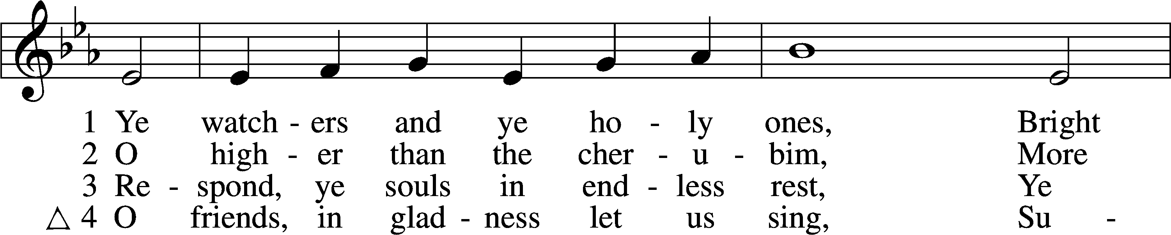
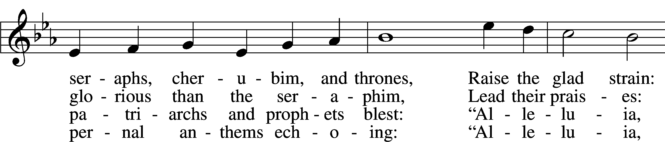
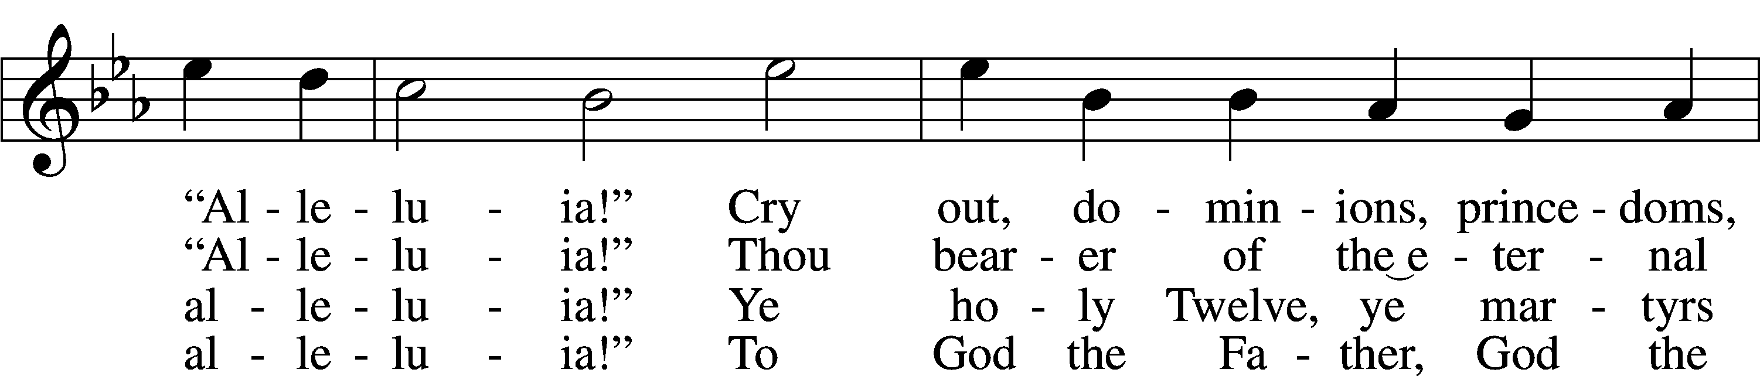
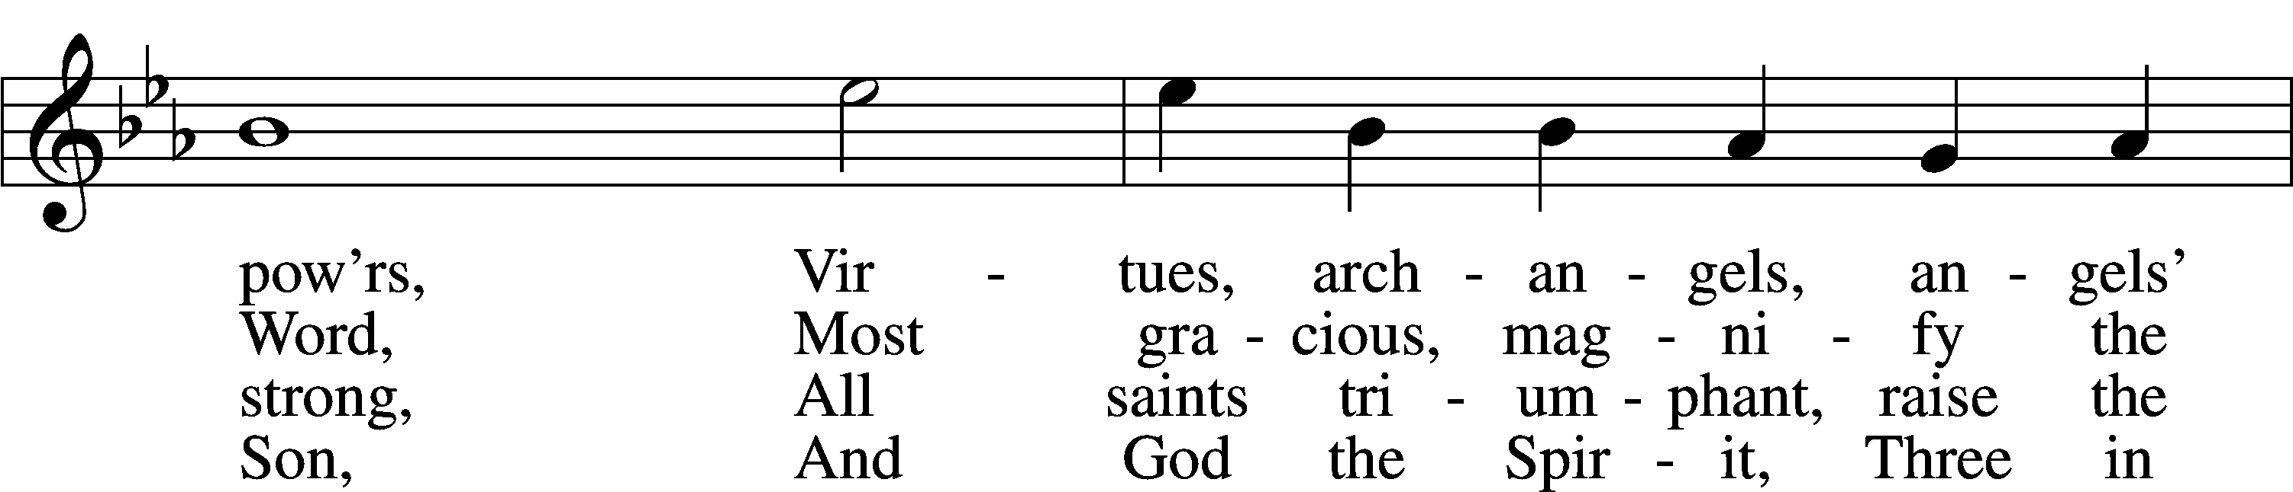
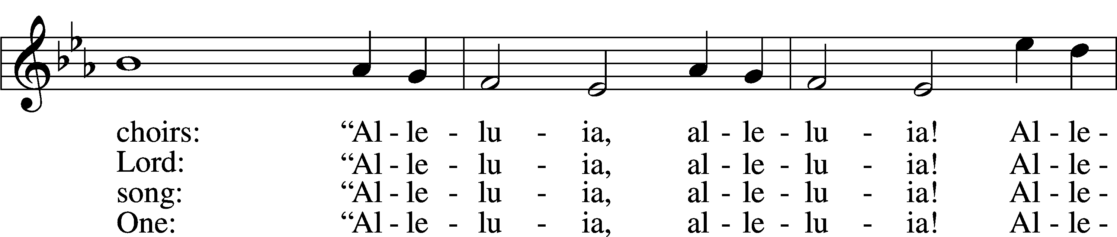
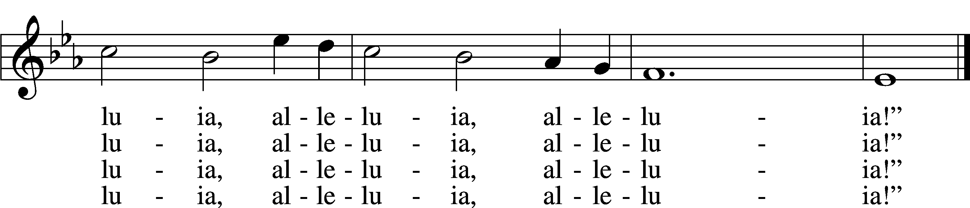

Text: J. Athelstan L. Riley, 1858–1945, alt.
Tune: Geistliche Kirchengesäng, 1623, Köln
Text and tune: Public domain

ANNOUNCEMENTS and SENDING WORDS
P We go to live for Jesus!
C We go to share His love!

Acknowledgments
Unless otherwise indicated, Scripture quotations are from the ESV® Bible (The Holy Bible, English Standard Version®), copyright © 2001 by Crossway, a publishing ministry of Good News Publishers. Used by permission. All rights reserved. Created by Lutheran Service Builder© Concordia Publishing House.

NEXT WEEKS READINGS
First Reading: Acts 1:12-26
Epistle: Revelation 21:1-21
Holy Gospel: John 17:20-26

SERVING in GODS HOUSE TODAY
Pastor: Rev. Paul Schneider
Elder: Tim Arner
Ushers: Joann & Larry Whitney
Greeters: Appold Family
Coffee: Judi & John Stutzman
Counters: Janet Arner, Kathy Erat
Altar Care: Ann Mertz
Piano/Organ: Jean & Tom Beach
Children’s Talk: Nancy Ely
PRAYERS
Please contact the office with updates to the prayer list. People will remain on the prayer list for 4 weeks before being removed. If they need to remain on the list, please keep Elaine informed and of any updates. This will help us to have a more accurate list. Thanks for your cooperation.

Those who continue to grieve the passing of loved ones, The Family of Karen Christoff, and the family of Ruth Luebs.
Those with upcoming surgery:
Those recovering from surgery: Ron Kwapis, Sasha (Rose Dittmans Grandson), and Tanner Beyers .
Those with health concerns: Tiffany Amsdill, Laurie Breen, Hope Buchinger, Betsy Cook Kay Gregg, Hilda Koch, Eleanor Raether, Beth Smith, Judi Stutzman, and Joann Whitney.
Those diagnosed with cancer: Leah Eicher, Maria Freimark, Rachel Frisch, Joe Gibson, Janice Knoellinger, Leslie Martin, Brian Morgan, Hope Osantowski,, Ken Radke, and John Stutzman.
Those under Hospice Home Care: Ken Williamson.

BIRTHDAYS:
5/24 Sharon Kowalsky
5/24 Delores Mouch
5/28 Harold Armstrong

ANNIVERSARIES;
5/22 Carla & Jon Elenz
5/22 Sharon & Ron Kwapis
5/29 Rachel & Derrick; Woiderski

MESSAGES
ALTAR FLOWERS Last week were given to the Glory of God by

MEMBER & GUEST CARDS: If you have not filled out a member/guest card, please take the time to fill one out and place it in the plate behind the back pews in our sanctuary.

WEDNESDAY MORNING BIBLE STUDY, 10:00am in the fellowship hall with Pastor Ken Bernthal.

CANCER and FRIENDS SUPPORT GROUP: Will be meeting May 24th . We will be having a guest speaker Junita Morrison from the Cheboygan Cancer Group.. Remember Cancer & Friends Support Group is not just for people going through treatment, or survivors, we are also here for caregiver, spouse, children, and friends. During those difficult times we can all use someone to talk to. If there is any subject you would like to discuss with me you call or text or at 989-350-4391. Hope you will join us.

LWML SUMMER POP-UP CRAFT SALES: LWML plans to have occasional mini craft sales this summer. With short notice we will set up a few canopies in the front yard and offer our crafts for sale, with the profits designated for missions, both locally and throughout the world. Dates have yet to be determined. So, crafters, please get thinking about what handmade items you can prepare in advance for us to sell. We welcome and appreciate your donations.

JUNE NEWLSETTER DEADLINE: May, 23rd, and July Deadline is June 20th,
From now on the newsletter will be due the last Monday of the month before the last Sunday of the month.
CHURCH YARD CLEAN UP DAY today after church. We need as many people as we can get-the more hands the sooner we can get it done. Bring your gloves, rakes, wheel barrows, and be ready to work. We will be working inside and outside of the church. Lunch will be provided. There is a signup sheet posted on the board in the narthex.
ALTAR FLOWERS: There are still spots open for Altar flowers, if you have birthdays, anniversaries, new baby or in memory of someone, or just for something special like dressing up the Altar. The signup sheet is in the fellowship hall as you go in the door. Flowers are $30.00 for the two flowers. Order them, they will be put on the altar, after the service then take them home to enjoy.

THIS WEEK AT TRINITY
May22 Sunday
9:00 am Worship Service - Holy Communion – Rev. Ken Bernthal
10:00 am Fellowship & Coffee Hour
10:30 am Bible Study with Dr. Tom Beach (Tutoring Room)
10:00 am Church yard clean up after the service
May 23 Monday
DEADLINE FOR JULY NEWSLETTER
7:00 pm Choir
May 24 Tuesday
5:30 pm Cancer & Friends Support Group (everyone is welcome)
May 25 Wednesday
10:00 am Wednesday Morning Bible Study W/ Pastor Ken Bernthal
May 26 Thursday
May 27 Friday
May 28 Saturday
May 29 Sunday
9:00 am Worship Service - Holy Communion – Rev. Paul Schneider
10:00 am Fellowship & Coffee Hour
10:30 am Bible Study with Dr. Tom Beach (Tutoring Room)

